**Reading food labels**

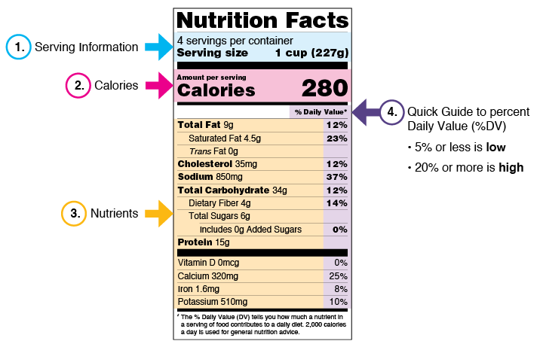

All packaged foods are required to display a standardized nutrition label. This

nutrition label contains information about the caloric content, amount of fat, protein,

carbohydrates, and other required nutrients.

1. Examine the following nutrition labels and answer the questions.

a. How many calories would you consume if you ate the whole

box of crackers in one sitting? __________________________

b. If you ate 2 servings of crackers, how many Milligrams of

sodium would you consume? ___________________

c. If you ate 15 crackers what would be the total calories consumed? ___________________

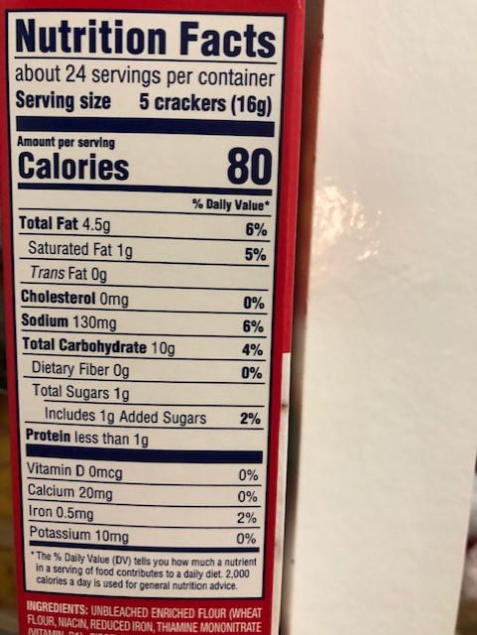

2. Examine the following nutrition labels and answer the questions.

a. How many calories would you consume if you drank the entire 20-ounce Dr. Pepper? __________________________

b. How many total carbs are in this drink? ___________________

c. How many added sugars in this drink? ___________________

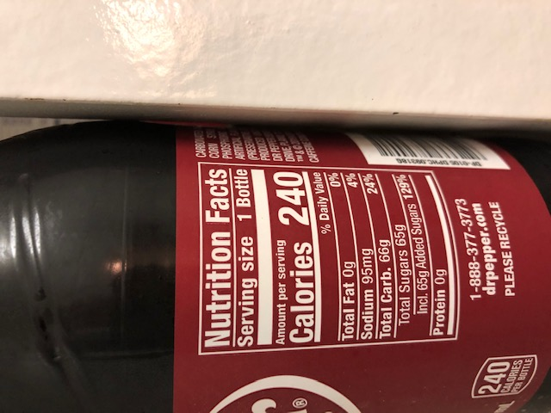

3. Examine the following nutrition labels and answer the questions.

a. How many calories would you

consume if you ate the whole

bag? _____________________

b. How many carbohydrates would

you consume if you ate the whole

bag? _____________________

c. How much fat would you get

from eating 5 servings of Doritos?

_____________________

Doritos

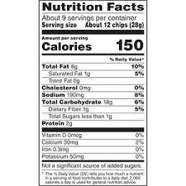

4. Examine the following nutrition labels and answer the questions.

a. If you were to eat the entire can of soup, how much

sodium would you consume? ___________________

b. How many servings of soup would I need to consume

20% of my daily requirement of fiber? _________________

Chicken noodle soup

